# Page Object Model and Page Factory in Selenium

Page Object Model, also known as POM, is a design pattern in Selenium that creates an object repository for storing all web elements. It helps reduce code duplication and improves test case maintenance.

In Page Object Model, consider each web page of an application as a class file. Each class file will contain only corresponding web page elements. Using these elements, testers can perform operations on the website under test.

A design patterns are **well-proven solution** for solving a specific problem/task.

**Page Object Model Design Pattern**

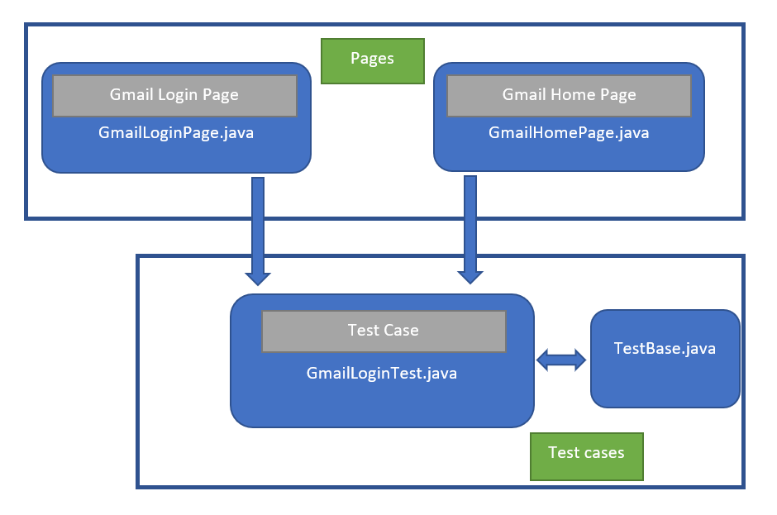

### **Advantages of Page Object Model Framework:**

* **Code reusability – We could achieve code reusability by writing the code once and use it in different tests.**
* **Code maintainability – There is a clean separation between test code and page specific code such as locators and layout which becomes very easy to maintain code. Code changes only on Page Object Classes when a UI change occurs. It enhances test maintenance and reduces code duplication.**
* **Object Repository – Each page will be defined as a java class. All the fields in the page will be defined in an interface as members. The class will then implement the interface.**
* **Readability – Improves readability due to clean separation between test code and page specific code**

**Implementation of Page Object Model:  
Here I’m taking the example of Gmail application to show the implementation of POM.  
The Project Hierarchy of my Maven Project is shown below:**

**Project Hierarchy  
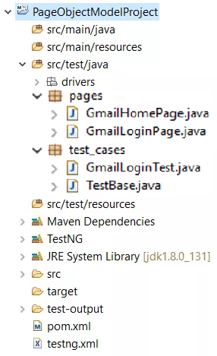**

### **What is Page Factory:**

**We have seen that ‘Page Object Model’ is a way of representing an application in a test framework. For every ‘page’ in the application, we create a Page Object to reference the ‘page’ whereas a ‘Page Factory’ is one way of implementing the ‘Page Object Model’.**

### **What is the difference between Page Object Model (POM) and Page Factory:**

**Page Object is a class that represents a web page and hold the functionality and members.  
Page Factory is a way to initialize the web elements you want to interact with within the page object when you create an instance of it.**

**Framework Creation:**

1. **We are going to create a maven project**
2. **We are going to have 3 packages (pages, tests, utility methods)**
3. **First we will write the utility methods for selenium tests. Then we will create Page class and finally we will create tests using selenium**
4. **Finally build reporting for the framework**